**Project Design Phase-II**

**Data Flow Diagram & User Stories**

| Date | 25 June 2025 |
| --- | --- |
| Team ID | LTVIP2025TMID32541 |
| Project Name | Smart Sorting: Transfer Learning for Identifying Rotten Fruits and Vegetables |
| Maximum Marks | 4 Marks |

**Data Flow Diagrams:**

A Data Flow Diagram (DFD) is a traditional visual representation of the information flows within a system. A neat and clear DFD can depict the right amount of the system requirement graphically. It shows how data enters and leaves the system, what changes the information, and where data is stored.

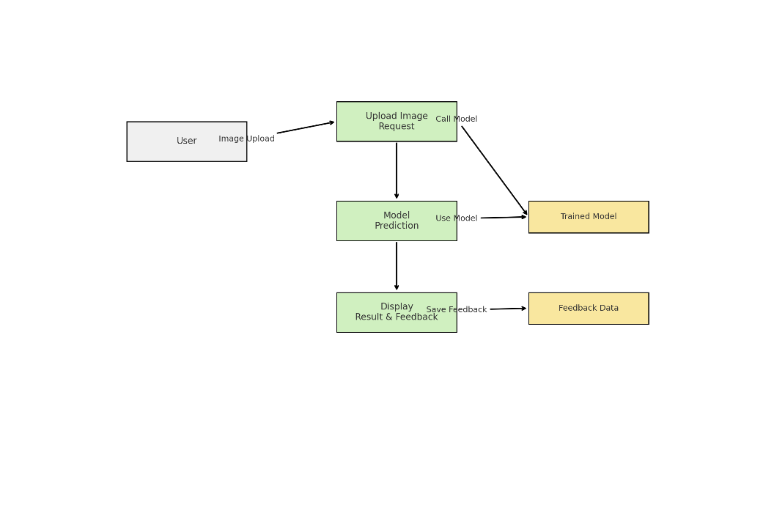

**User Stories**

| **User Type** | **Functional Requirement (Epic)** | **User Story Number** | **User Story / Task** | **Acceptance Criteria** | **Priority** | **Release** |
| --- | --- | --- | --- | --- | --- | --- |
| Customer (Web user) | Image Upload | USN-1 | As a user, I can upload an image of a fruit or vegetable | The image gets uploaded and processed | High | Sprint-1 |
| Customer | Classification | USN-2 | As a user, I can see if the uploaded item is Healthy or Rotten | Model shows class and confidence score | High | Sprint-1 |
| Customer | Classification | USN-3 | As a user, I get a label like “Good to Eat” or “Don’t Eat” based on the prediction | A result label is shown after prediction | High | Sprint-1 |
| Customer | Feedback Submission | USN-4 | As a user, I can submit feedback after prediction | The feedback is saved and acknowledged | Medium | Sprint-2 |
| Customer | History / Results | USN-5 | As a user, I can view the previous prediction result until the session ends | I can review previous result before re-uploading new image | Low | Sprint-2 |
| Customer Care Executive | Feedback Review | USN-6 | As support staff, I can view and export user feedback | I can access stored feedback for quality improvement | Medium | Sprint-2 |
| Administrator | Model Monitoring | USN-7 | As an admin, I can monitor model accuracy and update the model | Dashboard shows performance metrics and model status | Medium | Sprint-2 |
| Administrator | Data Management | USN-8 | As an admin, I can manage image dataset and trigger retraining | I can upload/remove images and start training job | Medium | Sprint-2 |